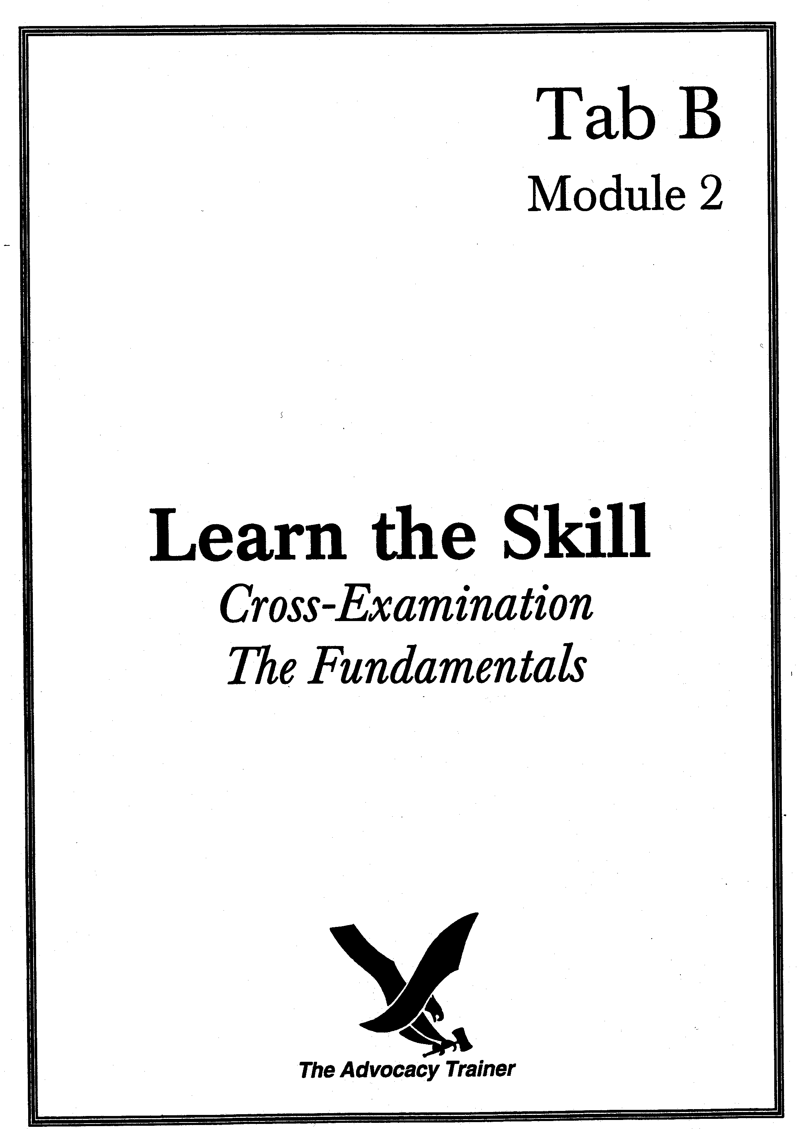
cross-examination - the fundamentals
supervisor’s guide

 skill overview.

Goals. The key to effective cross-examination is precise, single-fact leading questions. Your role as an advocate during cross-examination is to attack weaknesses in opposing counsel’s case and reinforce your theory of the case. These drills are designed to teach, reinforce and enhance counsel’s ability to effectively cross-examine. Background is provided for the supervisor and is followed by drills designed to achieve the basic skills. As in the first module, the emphasis is on form, not substance. Once the form (methodology) is mastered it can be applied to any substance (your specific case).

Training Overview. This training requires at least two participants: one supervisor and one counsel. The training is divided into various drills of short (15 minutes) or long (1 hour) duration depending on the time available to you. They are specifically designed to be used anywhere, with little or no preparation. Resources: time.

 the law.

The order of your case in chief. MRE 611.
- “The Military Judge shall exercise reasonable control over the mode and order of interrogating witnesses and presenting evidence.” MRE 611(a).
- “Leading questions should not be used on direct examination of a witness. Leading questions are permitted on cross-examination.” MRE 611(c).

 the art.

The Canvas: The goal of cross-examination is to attack and exploit weaknesses and to reinforce strengths. Unlike direct examination, you do not want witnesses explaining answers or responding with narratives. Counsel must maintain control of the witness. This goal is best accomplished through the use of single-fact, leading questions which force witnesses to answer “yes” or “no” to a series of propositions posed by counsel.

Focus: The following drills focus on the fundamental skill of single-fact, leading questions. This is a foundational skill for all trial lawyers. Regardless of experience, it is a skill which counsel must constantly sharpen.
- Caveat: This module focuses on single-fact, leading questions. Although such questions need not be “cross” in tenor, they must be single-fact and leading. Unquestionably, there are many “forms” of cross-examination. For example, “friendly” cross tends toward open-ended questions. Without experience this can lead to disaster. ONLY when counsel become more experienced should counsel venture away from single-fact, leading questions. As a supervisor, you must gauge your counsel’s experience level and capabilities.

Strategy: 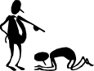
- Should Counsel Cross-Examine the Witness?  The threshold inquiry counsel must make for every witness is whether to cross- examine.
- Counsel must ask whether the witness can support his theory of the case, or hurt his opponent’s case. If the answer to both inquiries is no, don’t cross-examine. This might be the case for a chain of custody witness whose testimony on direct neither hurts counsel’s case nor particularly helps his opponent’s case. The witness is merely fulfilling a technical requirement of proof and so there is no need to waste the court’s time with cross-examination.
- Another reason to forego cross-examination is that the witness is not important to the fact-finder. Is it necessary to cross the confinement facility NCO who supervised the accused for three weeks while he was in pretrial confinement and testifies on sentencing that the accused is an American hero? Argument will suffice to put that witness’s testimony in proper perspective. Counsel must develop a sense of when such cross might serve a collateral purpose -- e.g., give a preview of a closing argument to a new panel -- even when it yields no concessions from the witness.
- Counsel might also forego cross-examination because there is no reasonable expectation of getting favorable testimony from the witness. For example, counsel often are unlikely to gain much by crossing the accused’s mother on sentencing.
- Finally, counsel must weigh the potential benefit of cross-examination against the potential that the witness will be able to rehabilitate himself during the cross, or on redirect.
- Identify the Purpose of Each Cross-examination.  Counsel must plan, based on interviews, witness statements, and last minute revelations made on direct examination, what he hopes to achieve through cross-examination.
- Counsel may seek testimony on cross that corroborates information provided by one of his witnesses. Even with a hostile witness, counsel can fill gaps in his case by getting the witness to corroborate details.
- Counsel may seek to discredit the testimony given on direct or seek to discredit the witness as a person. Inexperienced counsel must understand that testimony can be attacked without attacking the witness as a person. It is usually ill-advised to attack the 80 year-old kindly eyewitness. This does not endear you to the panel. Simply pointing out the weaknesses in the witness’s testimony is far more productive. The low key approach might be the best tactic if counsel’s objective is merely to poke holes in the direct testimony, based on the witness’s faulty perception, poor memory, or inartful recitation of facts on direct. However, when counsel needs to discredit the witness as a person, a more hard-edged, destructive cross-examination is required. This is quite common when an accused or an alibi witness testifies. These individuals often have a “dog in the fight” and it is up to counsel to expose this agenda or bias.
- Counsel may seek to impeach the witness, or his testimony through cross-examination. Bias, prior untruthful acts, convictions and inconsistent statements constitute fertile grounds for impeachment on cross-examination.

Tactics: 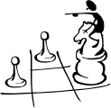
- The skill drills in this module do not focus on counsel’s grasp of a particular set of facts or the ability to prove or disprove an essential element. Instead, counsel must perfect the form of the question. Counsel must be able to ask a leading question in any given setting. Once counsel learn the basic skill, they can then use it in any setting, and with far greater impact and less anxiety.
- Leading questions are not really questions at all. They are declarative statements. They are affirmative propositions disguised as questions. They are “put to” the witness who must, because of the phrasing, either adopt the statement or reject it with minimal or no opportunity or expectation of explanation.
- “To Tag or Not to Tag”: Two “styles” of phraseology are used. The first is a leading question with a “tag.” “You own a baseball bat, don’t you.” The “tag” is “don’t you?” and takes many forms (e.g., didn’t you?, isn’t it true?, etc.). The other style is to drop the tag entirely. A leading question can still be asked with identical language but there is now a premium on inflection. Thus, “you own a baseball bat.” To be leading, the inflection must fall on “bat.” See Drill 1 for more detail.
- Because leading questions are not truly inquisitive in tenor or spirit, voice and inflection make the critical difference. This is especially true with non-tag, leading questions. Thus, the question, “you own a baseball bat” can be leading or non-leading. If the inflection drops when saying “bat,” it is leading. As discussed above, the falling inflection of the questioner does not reflect doubt or true inquisitiveness. If, however, your inflection rises on the “bat,” it demonstrates the questioner is uncertain or at least inviting an explanation.
- A good cross-examination question, therefore, is one that marries proper form with tailored inflection. This skill only comes with practice.

 practice pointers.
Although each cross-examination will vary depending on the information sought from the witness, there are fundamentals of an effective cross-examination that counsel should follow.

- “Cross-examination is a commando raid, not the invasion of Europe!” [Irving Younger] Limit the number of points sought from each witness. Too much information from one witness tends to obscure the truly important facts from the testimony. If counsel know important information can be obtained from follow-on witnesses, limit the points to be made by each individual.

- Primacy and Recency. Make strongest points at the beginning and end of cross- examination.

- Avoid the Ultimate Question! Counsel often ruin a successful cross-exam because they think the witness is on the ropes and will admit the critical, ultimate fact in issue. AVOID this temptation and save the inference for argument. Most witnesses will not play into your hands and “confess” on the stand. Save it for argument. Don’t be greedy!

- No expansive narratives. Questions should be short, single-fact, and leading. Counsel should lead the witness to a desired response and not allow the witness to give expansive narratives. There is seldom a place for “How” or “Why” or “Tell the court” lines of questioning.

- Mix it up! Judiciously use tags to direct the questioning. Prefacing every question with “Isn’t it true?” or ending every question with “wouldn’t you agree?” can be very distracting. When used sparingly, however, tags do help to maintain control of the witness and the direction of the cross-examination.

- Playing with fire. Do not ask questions to which you do not know the answer.

- Toolbox of control techniques. Develop canned responses to control hostile witnesses, such as, “perhaps you didn’t hear my question,” “so the answer is yes,” ”maybe you could answer my question this time,” “my question was ...” and so on. Seeking the judge’s assistance should always be a last resort.

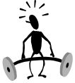 skill drills.

Goal: Train counsel to ask single-fact, leading questions.

Conduct the drills.

Preparation: You must practice these drills on your own (in front of the mirror, spouse, or in the car) or with a peer before you stand up in front of your counsel.

Role Play: Counsel must really “loosen up” to obtain the full benefit from these drills.

Execution: Get out of your office, away from the phones! Go to the courtroom. Supervisor should demonstrate what he expects from counsel. After a demonstration, the supervisor then selects counsel to do the entire drill or has counsel collectively perform the drill, randomly selecting counsel to perform a part of the exercise.

Drill 1: Inflection. “The Falling Inflection”

The supervisor explains how inflection dictates whether a query is leading or nonleading. As an example, if a witness is asked “you own a bat?” and the inflection (not volume) rises on the word “bat,” the witness perceives the questioner is uncertain of the answer and is honestly inquisitive. This invites an explanation from the witness. In cross, counsel don’t want explanations. The inflection must fall on “bat.” The witness will then hear a proposition. The falling inflection turns the tenor of the question into a declarative statement with which the witness will either agree or disagree. The falling inflection does not invite an explanation. With the falling inflection there is no “doubt” discernible in the questioner’s voice.

Mastering the falling inflection is sometimes made easier by starting first with “tags,” i.e., “don’t you?,” “didn’t you?,” “haven’t you?” Thus, “You hit Smith with a crowbar, didn’t you?” Counsel should first say this statement with the inflection rising on the “didn’t you?” Then counsel make the statement with the inflection falling on the “didn’t you.” If the inflection rises, regardless of the accusatory, declarative choice of words, it is not leading. The inflection must fall to be leading.

Work around the room and have counsel ask the following questions with a falling (leading) inflection. (See counsel handout for Drill 1). Hearing the “fall” is an important part of perfecting the ability to use the falling inflection.
- You drive a red car, don’t you?
- You never counseled the accused, did you?
- You’ve read the SOP?
- You had four margaritas at the bar?
- You took the ATM card from your roommate’s wall-locker, didn’t you?
- You tried to flush your system before the urinalysis, isn’t that right?

Drill 2: Form of the Question.

There are numerous cross-examination drills which help to improve counsel’s ability to ask a proper single-fact leading question. This drill is similar to direct examination drill 3 (level 1).

Just as counsel conducted direct examination on objects or events, the same information learned on direct now becomes the subject of cross. Thus, if we conduct a direct exam on breakfast, we can now “cross” armed with the necessary information. Thus,
- You ate breakfast?
- You ate at 0800 hours?
- You ate breakfast at Shoney’s?
- And you had pancakes didn’t you?
- In fact, you ate alone, didn’t you?
- And you spent $5.00?
- Each counsel should be required to perform in this fashion.

One technique is to have the same counsel conduct the direct exam and then immediately conduct the cross-examination with the information learned on direct. This technique has a number of benefits. It contrasts the ability to ask the questions in the proper form with the proper inflection. It also places a premium on the ability to listen to the answers. This drill is also constructive between two counsel. One counsel conducts the direct exam of you, and then another counsel, selected at random, is told to conduct a cross immediately after direct is concluded.

Drill 3: Cross-Examination of an Inanimate Object. (Level 1)
“Future surgeons practice on cadavers. Future dentists practice carving chalk. Trial lawyers can take a lesson from these practices.” [unknown]

Pair counsel off and have them sit in chairs facing one another. Give one counsel an object, for example, a staple remover, Magic Marker, 3-hole punch, wrist watch, or coin. The person holding the object will now speak as the object and answer only single-fact, leading questions. Counsel conducting the cross-examination must break the object down mentally and describe it through questions.

This drill forces counsel to state questions as propositions and to think from general to specific. The drill also demonstrates the power of descriptive questions such that counsel never need to ask the ultimate question.
Thus, a bar of soap would look something like this:

You are an inanimate object?
You are a three-dimensional figure?
You are rectangular in shape?
You are approximately four inches long?
You are approximately two and a half inches wide?
You are approximately one and a half inches deep?
You are white in color?
Your edges are rounded?
The word “Ivory” is pressed into you?

Note that the ultimate question, “You’re a bar of soap?” is NOT asked. Save it for argument. Don’t be greedy.

Drill 3: Inanimate Object. (Level 2)
Counsel can benefit from this drill outside the office setting as well. In fact, this drill is easily performed alone while one is, for example, mowing the lawn, taking a shower, driving to work or sitting in a staff call. Simply pick an object, e.g., the lawnmower, the shower head, the car radio or the boss’s shoe, and conduct a cross-examination.

Drill 3: Inanimate Object. (Level 3)
Select a counsel to conduct the inanimate object drill described above. This time, however, have remaining counsel put their heads down or close their eyes so they don’t know the object in question. As the examination develops, the listening counsel will raise their hands, but not open their eyes, when they think they know the object being described. This technique conveys to counsel the importance of descriptively breaking down an object and reconstructing it with leading questions. To paint a recognizable picture, it must go from general to specific.

Drill 4: The Eliminator.

Another variation on this theme is to place counsel in competition with one another by selecting a subject on which to cross-examine you. You must rule on improper questions. If counsel ask non-leading or otherwise objectionable questions, they are removed from the competition. The following scenarios may be used with this approach:

OPTION A
FACTS Given to Counsel: I am an accused on the witness stand. I was apprehended on the front steps of a house with a screwdriver in my hand. The window next to the front door is broken. I live 20 miles from this house
FACTS for Supervisor: I came to the house by car from my own home located 20 miles away. I brought the screwdriver with me along with a hammer, which was in the car. When I drove to the house I intended to break in. I broke the window next to the door and unlocked the door. I spent over an hour in the home and was only apprehended on my way out. No one was home except the dog, which I killed. It was my ex-wife’s dog. My ex-wife’s house. I just lost it in the divorce. I was going to set fire to the house but lost my nerve. So I just busted things up. Except my daughter’s room. It’s my house and my things inside. I hate the woman!
- Counsel should be able to develop many avenues of inquiry with these facts: intent to burgle and burn, actions in the house, relationship to house, divorce, etc.

- Counsel may complain that they’re asking questions to which they don’t know the answer or for which they have no good faith basis. That’s OK in this drill. The point of the drill is to focus on form only. The method of not knowing the facts is deliberate and intended to cause counsel to react on their feet, be creative, and have fun.
OPTION B

FACTS Given to Counsel: The accused is charged with murder by stabbing Jones in a bar fight. The witness on the stand claims the accused was with him the night of the stabbing.

FACTS for the Supervisor: I have known the accused for 10 years and he is my best friend. He was with me the night of the stabbing. We were in my apartment watching movies. We watched “Last Man Standing.” We were drinking beer together. Yes, we went to a bar together. I carry a switchblade. It’s a tough town. I knew the victim. I talked with the victim. We argued. Maybe I stabbed him, maybe I didn’t.

The drills discussed thus far are repetitive drills, that is, they can and should be done each time you meet with counsel. They can also be done with little or no preparation. And they are an excellent way of keeping counsel’s interrogation skills fresh and finely honed.

 Summarize the main teaching points. Following the drills, conduct a discussion of lessons learned and summarize the main points:
- Single-fact, leading questions are critical to success on cross- examination.
- You must listen to and maintain eye contact with your witness.
- Practice the use of inflection to call attention to certain testimony.



 references.

Steven Lubet, Modern Trial Advocacy (NITA 1993).

Thomas A. Mauet, Trial Techniques (4th ed. 1996).

James W. McElhaney, McElhaney’s Trial Notebook (3d ed. 1994).

James W. McElhaney, McElhaney’s Litigation (1995).

Leonard Packel and Dolores B. Spina, Trial Advocacy: A Systematic Approach (ALI-ABA 1984)

Louis E. Schwartz, Proof, Persuasion, and Cross-Examination: A Winning New Approach in the Courtroom (1973).

Herbert J. Stern, Trying Cases to Win - Cross-Examination (1993).

Michael E. Tigar, Examining Witnesses (1993).

ENCLOSURE
Counsel Handout
cross-examination - the fundamentals
counsel handout

 training overview.

Introduction. The next advocacy training session is on _______________, from ______ to ______ hours. We will focus on the skill of cross-examination. The training will be conducted in two parts. First, I will lead a discussion about the various skills necessary for an effective cross-examination. After a short break, we will reconvene for the second part of the training, during which we will conduct a series of short advocacy drills intended to reinforce the skills and techniques addressed in the first part of the training.

Preparation. Bring your Military Judge’s Benchbook, Manual for Courts-Martial, and an evidentiary foundations text to this and every future trial advocacy training session. You must also review and be prepared to discuss the facts of one of your current cases. Finally, review and be prepared to discuss the cross-examination skills listed below.

 keys to success.

Threshold Inquiry: Do I Need to Cross-Examine the Witness at All? 

Can the witness support your theory of the case, or hurt your opponent’s case? If the answer to both inquiries is no, leave the witness alone.

Is the witness important to the fact-finder? Even if you can make a point by cross-examining the witness, is the point worth making?

Is there a reasonable expectation of getting favorable testimony from the witness? Are you going to cross the accused’s mother? How about a rape victim’s husband?

What is the cost of cross-examination? Will the witness rehabilitate himself? Will your opponent kill you on redirect?

What is the Purpose of Each Cross-Examination You Conduct?

Corroborate other testimony.

Impeach other testimony. Faulty perception? Memory? Prior inconsistent testimony?

Impeach the Witness. 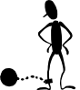 Bias? Prior Bad Acts? Reputation? Convictions?

Mechanics of Effective Cross-Examination. 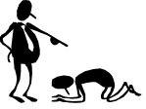

Limit the number of points sought from each witness.

Think primacy and recency, i.e., making your strongest points at the beginning and end of your examination.

Questions should be short, single-fact, and leading.

“You would agree” that tags should be used judiciously, “isn’t that true?”

 Avoid questions to which you do not know the answer.

Refrain from asking one too many questions. Get facts from the witness, do not seek conclusions.

Develop strategies to control hostile witnesses. Seeking the judge’s assistance should be a last resort.

 references for further study.

Steven Lubet, Modern Trial Advocacy (NITA 1993).

Thomas A. Mauet, Trial Techniques (4th ed. 1996).

James W. McElhaney, McElhaney’s Trial Notebook (3d ed. 1994).

James W. McElhaney, McElhaney’s Litigation (1995).

Leonard Packel and Dolores B. Spina, Trial Advocacy: A Systematic Approach (ALI-ABA 1984).

Louis E. Schwartz, Proof, Persuasion, and Cross-Examination: A Winning New Approach in the Courtroom (1973).

Herbert J. Stern, Trying Cases to Win - Cross-Examination (1993).

Michael E. Tigar, Examining Witnesses (1993).

Drill 1: Inflection. “The Falling Inflection”
- You drive a red car, don’t you?
- You never counseled the accused, did you?
- You’ve read the SOP?
- You had four margaritas at the bar?
- You took the ATM card from your roommate’s wall-locker, didn’t you?
- You tried to flush your system before the urinalysis, isn’t that right?

